**Group 3**

**Project Management Methods and Tools - Semester 1 Group Project**

**Project Management Software**

To manage the project we will be using Trello for our project management software. We liked the ability to easily group cards (stories) into buckets with easy drag and drop controls.

We found a good public template for a Trello scrum board and are using this as the basis for organising our project initially (source: <https://trello.com/b/Nr3RvsY1/>). There are also extensions to add burndown chart and more detailed scrum sprint management which we’ve attached to our board, in addition to the standard calendar, voting and card aging features. Our board can be found here: <https://trello.com/b/9OhPluxC/real-estate-website>

**Software Development Methodology**

We will be using Scrum as our agile software development methodology for the project. This will allow us to handle changes to the project as they come in a flexible manner, with continuous development and documentation.

Trello will allow us to manage the project using the Agile Scrum methodology.

**Source Control System and Collaboration Software**

For source control we are using Git using a private Git repository on Github. With git as a version/source control system, team members can work on the code base on their own machines working on features/development branches in isolation until the sprint is finished. When they’re ready they create a pull request to merge their changes with the master branch, after being reviewed by the team. Changes are tracked and can be reverted providing evidence of progression and a rollback feature if a bug is discovered.

Git is widely used in industry and is supported on all major OS platforms, with a multitude of guides and resources available to ensure efficient usage when managing our code and versioning.

For collaboration we will use Slack for messaging and file sharing, along with email and regular meetings after/before classes at TAFE. Also we have created a shared Google Drive folder where we will store assignment/project documents and allow multiple users to work together using Google Docs, Sheets and Slides. We’re also using Google Groups to have one email address for contact with the client.

**Links for Access**

The following links can be used to access our environments.

Trello (invite may be requried): <https://trello.com/b/9OhPluxC/real-estate-website>

Github (invite may be required): <https://github.com/slehmann36/Group3-Realestate-Site>

Drive folder: <https://drive.google.com/folderview?id=0BzjvBNtNDEyNS1p1THUyY1lnXzQ&usp=sharing>

Google Groups: <https://groups.google.com/forum/#!forum/tafegroup-3>

**Screenshots**

Trello:

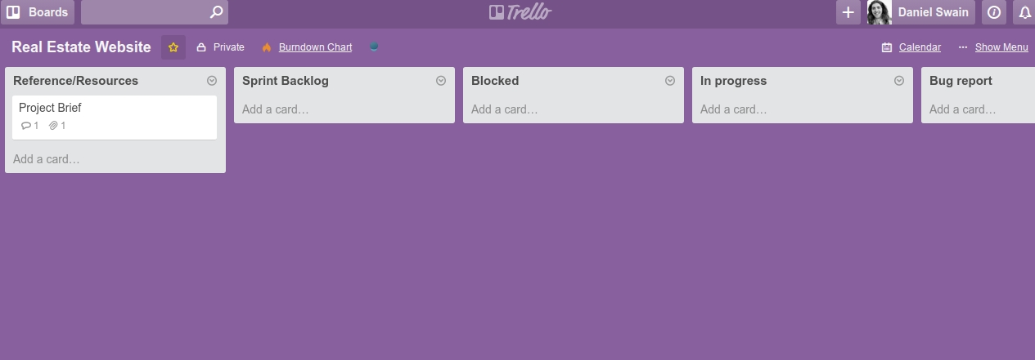

Github:

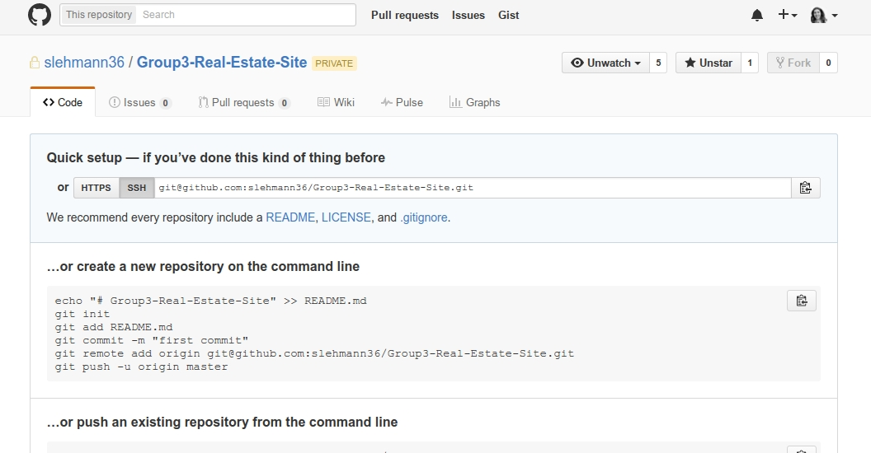

Google Drive:

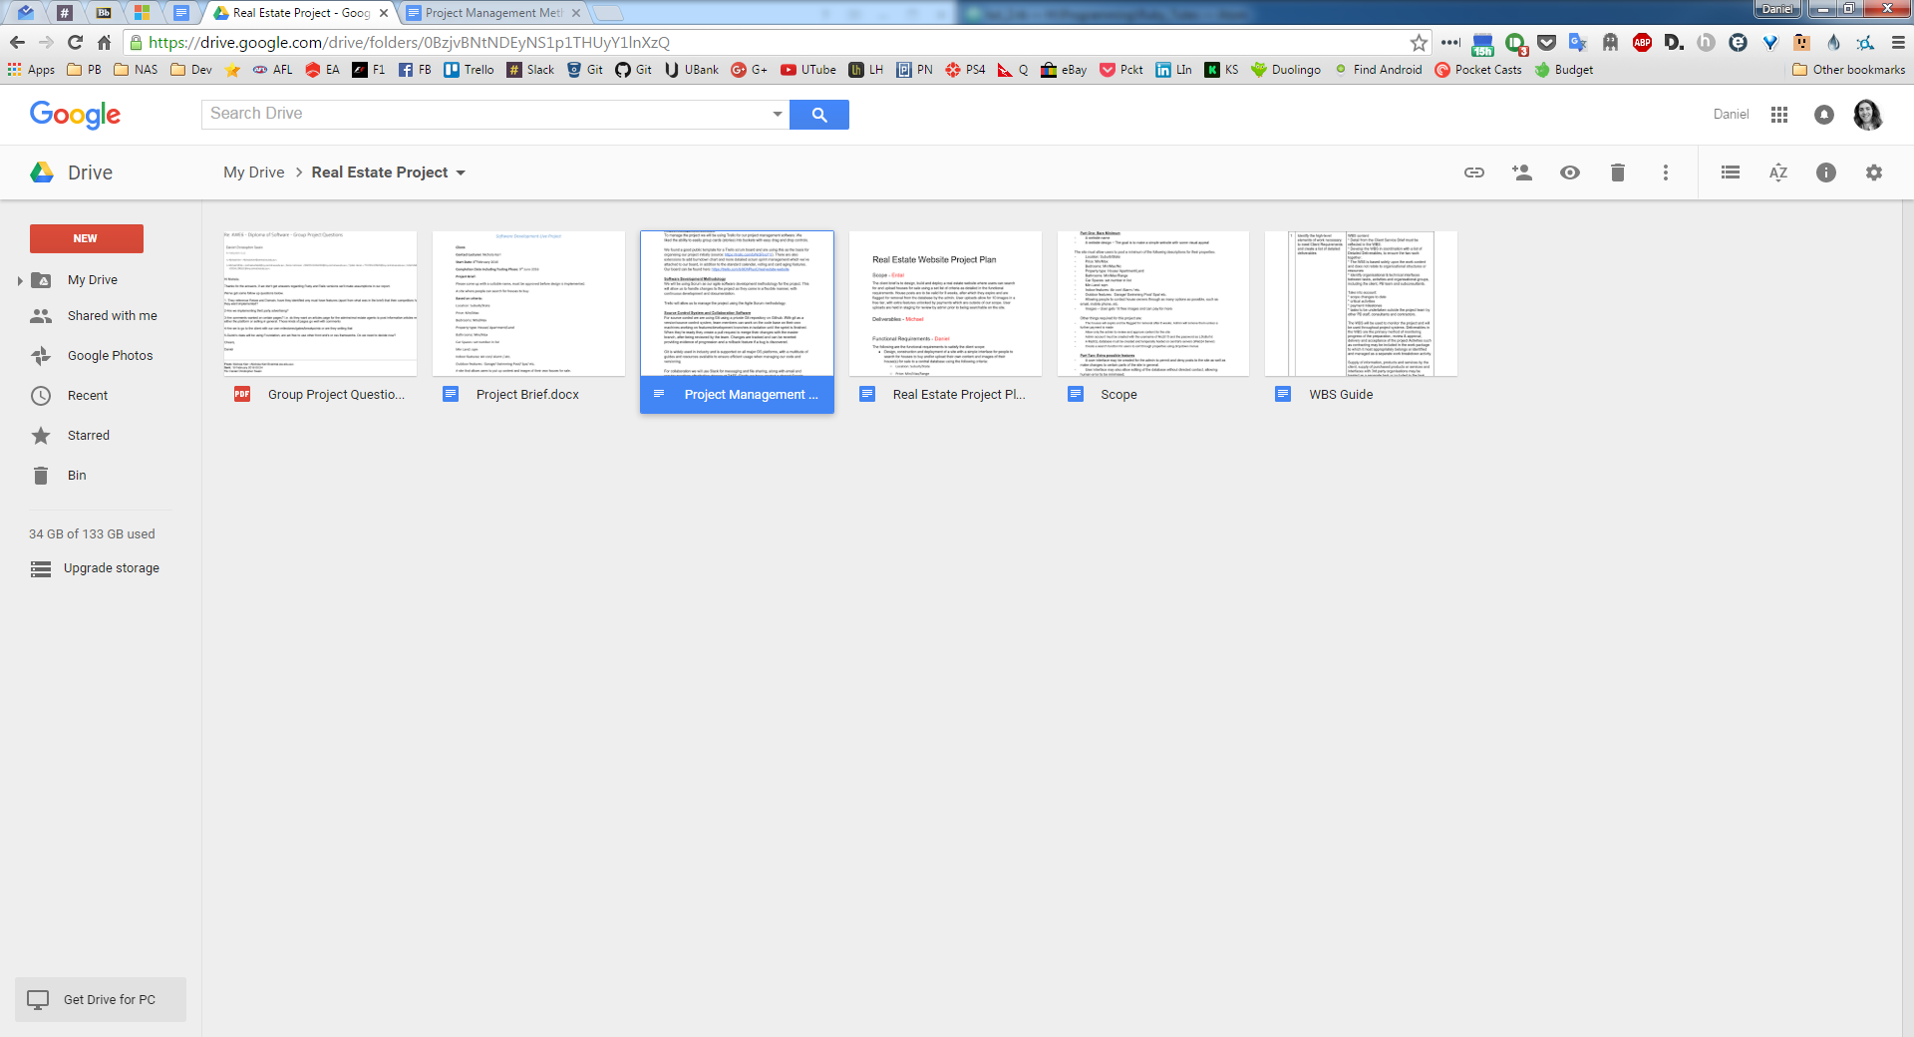

Google Groups:

